Deer Park Primary School
MATHS CURRICULUM

Our Ultimate End Goal:
What will our Mathematicians to be able to do when they leave Deer Park?
- By the end of their time at Deer Park Primary School our Year 6 children will have a deep understanding of maths and number
- They show a positive and resilient attitude towards mathematics and an awareness of the fascination of mathematics as well as having competence and confidence in mathematical knowledge, concepts and skills
- Our children will have an ability to solve problems, to reason, to think logically and to work systematically and accurately
- They will be able to use a range of learning strategies: working both collaboratively and independently
- Children will leave Deer Park being independent learners who take responsibility for their own learning and who have an understanding of the importance of mathematics in everyday life
- They will show fluency in mathematics and be able to express ideas confidently and talk about the subject using mathematical language.

EYFS and KS1 Curriculum Coverage (NC)
What are the most basic requirements from the National Curriculum?
EYFS | Year 1 | Year 2
 | Number - number and place value  Count to and across 100, forwards and backwards, beginning with 0 or 1, or from any given number  Count, read and write numbers to 100 in numerals; count in multiples of 2s, 5s and 10s  Given a number, identify 1 more and 1 less  Identify and represent numbers using objects and pictorial representations including the number line, and use the language of: equal to, more than, less than (fewer), most, least  Read and write numbers from 1 to 20 in numerals and words  Number - addition and subtraction  Read, write and interpret mathematical statements involving addition (+), subtraction (−) and equals (=) signs  Represent and use number bonds and related subtraction facts within 20  Add and subtract one-digit and two-digit numbers to 20, including 0  Solve one-step problems that involve addition and subtraction, using concrete objects and pictorial representations, and missing number problems such as 7 = ? – 9  Number - multiplication and division  Solve one-step problems involving multiplication and division, by calculating the answer using concrete objects, pictorial representations and arrays with the support of the teacher  Number - fractions  Recognise, find and name a half as 1 of 2 equal parts of an object, shape or quantity  Recognise, find and name a quarter as 1 of 4 equal parts of an object, shape or quantity  Measurement  Compare, describe and solve practical problems for:  Lengths and heights [for example, long/short, longer/shorter, tall/short, double/half]  Mass/weight [for example, heavy/light, heavier than, lighter than]  Capacity and volume [for example, full/empty, more than, less than, half, half full, quarter]  Time [for example, quicker, slower, earlier, later]  Measure and begin to record the following:  Lengths and heights  Mass/weight  Capacity and volume  Time (hours, minutes, seconds)  Recognise and know the value of different denominations of coins and notes  Sequence events in chronological order using language [for example, before and after, next, first, today, yesterday, tomorrow, morning, afternoon and evening]  Recognise and use language relating to dates, including days of the week, weeks, months and years  Tell the time to the hour and half past the hour and draw the hands on a clock face to show these times  Geometry - properties of shapes  Recognise and name common 2-D and 3-D shapes, including:  2-D shapes [for example, rectangles (including squares), circles and triangles]  3-D shapes [for example, cuboids (including cubes), pyramids and spheres]  Geometry - position and direction  Describe position, direction and movement, including whole, half, quarter and three-quarter turns | Number - number and place value  Count in steps of 2, 3, and 5 from 0, and in 10s from any number, forward and backward  Recognise the place value of each digit in a two-digit number (10s, 1s)  Identify, represent and estimate numbers using different representations, including the number line  Compare and order numbers from 0 up to 100; use <, > and = signs  Read and write numbers to at least 100 in numerals and in words  Use place value and number facts to solve problems  Number - addition and subtraction  Solve problems with addition and subtraction:  Using concrete objects and pictorial representations, including those involving numbers, quantities and measures  Applying their increasing knowledge of mental and written methods  Recall and use addition and subtraction facts to 20 fluently, and derive and use related facts up to 100  Add and subtract numbers using concrete objects, pictorial representations, and mentally, including:  A two-digit number and 1s  A two-digit number and 10s  2 two-digit numbers  Adding 3 one-digit numbers  Show that addition of 2 numbers can be done in any order (commutative) and subtraction of 1 number from another cannot  Recognise and use the inverse relationship between addition and subtraction and use this to check calculations and solve missing number problems  Number - multiplication and division  Recall and use multiplication and division facts for the 2, 5 and 10 multiplication tables, including recognising odd and even numbers  Calculate mathematical statements for multiplication and division within the multiplication tables and write them using the multiplication (×), division (÷) and equals (=) signs  Show that multiplication of 2 numbers can be done in any order (commutative) and division of 1 number by another cannot  Solve problems involving multiplication and division, using materials, arrays, repeated addition, mental methods, and multiplication and division facts, including problems in contexts  Number - fractions  Recognise, find, name and write fractions , , and of a length, shape, set of objects or quantity  Write simple fractions, for example of 6 = 3 and recognise the equivalence of and  Measurement  Choose and use appropriate standard units to estimate and measure length/height in any direction (m/cm); mass (kg/g); temperature (°C); capacity (litres/ml) to the nearest appropriate unit, using rulers, scales, thermometers and measuring vessels  Compare and order lengths, mass, volume/capacity and record the results using >, < and =  Recognise and use symbols for pounds (£) and pence (p); combine amounts to make a particular value  Find different combinations of coins that equal the same amounts of money  Solve simple problems in a practical context involving addition and subtraction of money of the same unit, including giving change  Compare and sequence intervals of time  Tell and write the time to five minutes, including quarter past/to the hour and draw the hands on a clock face to show these times  Know the number of minutes in an hour and the number of hours in a day  Geometry - properties of shapes  Identify and describe the properties of 2-D shapes, including the number of sides, and line symmetry in a vertical line  Identify and describe the properties of 3-D shapes, including the number of edges, vertices and faces  Identify 2-D shapes on the surface of 3-D shapes, [for example, a circle on a cylinder and a triangle on a pyramid]  Compare and sort common 2-D and 3-D shapes and everyday objects  Geometry - position and direction  Order and arrange combinations of mathematical objects in patterns and sequences  Use mathematical vocabulary to describe position, direction and movement, including movement in a straight line and distinguishing between rotation as a turn and in terms of right angles for quarter, half and three-quarter turns (clockwise and anti-clockwise)  Statistics  Interpret and construct simple pictograms, tally charts, block diagrams and tables  Ask and answer simple questions by counting the number of objects in each category and sorting the categories by quantity  Ask-and-answer questions about totalling and comparing categorical data

KS2 Curriculum Coverage (NC)
What are the most basic requirements from the National Curriculum?
Year 3 | Year 4 | Year 5 | Year 6
Number - number and place value  Count from 0 in multiples of 4, 8, 50 and 100; find 10 or 100 more or less than a given number  Recognise the place value of each digit in a 3-digit number (100s, 10s, 1s)  Compare and order numbers up to 1,000  Identify, represent and estimate numbers using different representations  Read and write numbers up to 1,000 in numerals and in words  Solve number problems and practical problems involving these ideas  Number - addition and subtraction  Add and subtract numbers mentally, including:  A three-digit number and 1s  A three-digit number and 10s  A three-digit number and 100s  Add and subtract numbers with up to 3 digits, using formal written methods of columnar addition and subtraction  Estimate the answer to a calculation and use inverse operations to check answers  Solve problems, including missing number problems, using number facts, place value, and more complex addition and subtraction  Number - multiplication and division  Recall and use multiplication and division facts for the 3, 4 and 8 multiplication tables  Write and calculate mathematical statements for multiplication and division using the multiplication tables that they know, including for two-digit numbers times one-digit numbers, using mental and progressing to formal written methods  Solve problems, including missing number problems, involving multiplication and division, including positive integer scaling problems and correspondence problems in which n objects are connected to m objects  Number - fractions  Count up and down in tenths; recognise that tenths arise from dividing an object into 10 equal parts and in dividing one-digit numbers or quantities by 10  Recognise, find and write fractions of a discrete set of objects: unit fractions and non-unit fractions with small denominators  Recognise and use fractions as numbers: unit fractions and non-unit fractions with small denominators  Recognise and show, using diagrams, equivalent fractions with small denominators  Add and subtract fractions with the same denominator within one whole [for example, + = ]  Compare and order unit fractions, and fractions with the same denominators  Solve problems that involve all of the above  Measurement  Measure, compare, add and subtract: lengths (m/cm/mm); mass (kg/g); volume/capacity (l/ml)  Measure the perimeter of simple 2-D shapes  Add and subtract amounts of money to give change, using both £ and p in practical contexts  Tell and write the time from an analogue clock, including using Roman numerals from I to XII, and 12-hour and 24-hour clocks  Estimate and read time with increasing accuracy to the nearest minute; record and compare time in terms of seconds, minutes and hours; use vocabulary such as o’clock, am/pm, morning, afternoon, noon and midnight  Know the number of seconds in a minute and the number of days in each month, year and leap year  Compare durations of events [for example, to calculate the time taken by particular events or tasks]  Geometry - properties of shapes  Draw 2-D shapes and make 3-D shapes using modelling materials; recognise 3-D shapes in different orientations and describe them  Recognise angles as a property of shape or a description of a turn  Identify right angles, recognise that 2 right angles make a half-turn, 3 make three-quarters of a turn and 4 a complete turn; identify whether angles are greater than or less than a right angle  Identify horizontal and vertical lines and pairs of perpendicular and parallel lines  Statistics  Interpret and present data using bar charts, pictograms and tables  Solve one-step and two-step questions [for example ‘How many more?’ and ‘How many fewer?’] using information presented in scaled bar charts and pictograms and tables | Number - number and place value  Count in multiples of 6, 7, 9, 25 and 1,000  Find 1,000 more or less than a given number  Count backwards through 0 to include negative numbers  Recognise the place value of each digit in a four-digit number (1,000s, 100s, 10s, and 1s)  Order and compare numbers beyond 1,000  Identify, represent and estimate numbers using different representations  Round any number to the nearest 10, 100 or 1,000  Solve number and practical problems that involve all of the above and with increasingly large positive numbers  Read Roman numerals to 100 (I to C) and know that over time, the numeral system changed to include the concept of 0 and place value  Number - addition and subtraction  Add and subtract numbers with up to 4 digits using the formal written methods of columnar addition and subtraction where appropriate  Estimate and use inverse operations to check answers to a calculation  Solve addition and subtraction two-step problems in contexts, deciding which operations and methods to use and why  Number - multiplication and division  Recall multiplication and division facts for multiplication tables up to 12 × 12  Use place value, known and derived facts to multiply and divide mentally, including: multiplying by 0 and 1; dividing by 1; multiplying together 3 numbers  Recognise and use factor pairs and commutativity in mental calculations  Multiply two-digit and three-digit numbers by a one-digit number using formal written layout  Solve problems involving multiplying and adding, including using the distributive law to multiply two-digit numbers by 1 digit, integer scaling problems and harder correspondence problems such as n objects are connected to m objects  Number - fractions (including decimals)  Recognise and show, using diagrams, families of common equivalent fractions  Count up and down in hundredths; recognise that hundredths arise when dividing an object by 100 and dividing tenths by 10  Solve problems involving increasingly harder fractions to calculate quantities, and fractions to divide quantities, including non-unit fractions where the answer is a whole number  Add and subtract fractions with the same denominator  Recognise and write decimal equivalents of any number of tenths or hundreds  Recognise and write decimal equivalents to , ,  Find the effect of dividing a one- or two-digit number by 10 and 100, identifying the value of the digits in the answer as ones, tenths and hundredths  Round decimals with 1 decimal place to the nearest whole number  Compare numbers with the same number of decimal places up to 2 decimal places  Solve simple measure and money problems involving fractions and decimals to 2 decimal places  Measurement  Convert between different units of measure [for example, kilometre to metre; hour to minute]  Measure and calculate the perimeter of a rectilinear figure (including squares) in centimetres and metres  Find the area of rectilinear shapes by counting squares  Estimate, compare and calculate different measures, including money in pounds and pence  Read, write and convert time between analogue and digital 12- and 24-hour clocks  Solve problems involving converting from hours to minutes, minutes to seconds, years to months, weeks to days  Geometry - properties of shapes  Compare and classify geometric shapes, including quadrilaterals and triangles, based on their properties and sizes  Identify acute and obtuse angles and compare and order angles up to 2 right angles by size  Identify lines of symmetry in 2-D shapes presented in different orientations  Complete a simple symmetric figure with respect to a specific line of symmetry  Geometry - position and direction  Describe positions on a 2-D grid as coordinates in the first quadrant  Describe movements between positions as translations of a given unit to the left/right and up/down  Plot specified points and draw sides to complete a given polygon  Statistics  Interpret and present discrete and continuous data using appropriate graphical methods, including bar charts and time graphs  Solve comparison, sum and difference problems using information presented in bar charts, pictograms, tables and other graphs | Number - number and place value  Read, write, order and compare numbers to at least 1,000,000 and determine the value of each digit  Count forwards or backwards in steps of powers of 10 for any given number up to 1,000,000  Interpret negative numbers in context, count forwards and backwards with positive and negative whole numbers, including through 0  Round any number up to 1,000,000 to the nearest 10, 100, 1,000, 10,000 and 100,000  Solve number problems and practical problems that involve all of the above  Read Roman numerals to 1,000 (M) and recognise years written in Roman numerals  Number - addition and subtraction  Add and subtract whole numbers with more than 4 digits, including using formal written methods (columnar addition and subtraction)  Add and subtract numbers mentally with increasingly large numbers  Use rounding to check answers to calculations and determine, in the context of a problem, levels of accuracy  Solve addition and subtraction multi-step problems in contexts, deciding which operations and methods to use and why  Number - multiplication and division  Identify multiples and factors, including finding all factor pairs of a number, and common factors of 2 numbers  Know and use the vocabulary of prime numbers, prime factors and composite (non-prime) numbers  Establish whether a number up to 100 is prime and recall prime numbers up to 19  Multiply numbers up to 4 digits by a one- or two-digit number using a formal written method, including long multiplication for two-digit numbers  Multiply and divide numbers mentally, drawing upon known facts  Divide numbers up to 4 digits by a one-digit number using the formal written method of short division and interpret remainders appropriately for the context  Multiply and divide whole numbers and those involving decimals by 10, 100 and 1,000  Recognise and use square numbers and cube numbers, and the notation for squared (²) and cubed (³)  Solve problems involving multiplication and division, including using their knowledge of factors and multiples, squares and cubes  Solve problems involving addition, subtraction, multiplication and division and a combination of these, including understanding the meaning of the equals sign  Solve problems involving multiplication and division, including scaling by simple fractions and problems involving simple rates  Number - fractions (including decimals and percentages)  Compare and order fractions whose denominators are all multiples of the same number  Identify, name and write equivalent fractions of a given fraction, represented visually, including tenths and hundredths  Recognise mixed numbers and improper fractions and convert from one form to the other and write mathematical statements > 1 as a mixed number [for example, + = = 1 ]  Add and subtract fractions with the same denominator, and denominators that are multiples of the same number  Multiply proper fractions and mixed numbers by whole numbers, supported by materials and diagrams  Read and write decimal numbers as fractions [for example, 0.71 = ]  Recognise and use thousandths and relate them to tenths, hundredths and decimal equivalents  Round decimals with 2 decimal places to the nearest whole number and to 1 decimal place  Read, write, order and compare numbers with up to 3 decimal places  Solve problems involving number up to 3 decimal places  Recognise the per cent symbol (%) and understand that per cent relates to ‘number of parts per 100’, and write percentages as a fraction with denominator 100, and as a decimal fraction  Solve problems which require knowing percentage and decimal equivalents of , , , , and those fractions with a denominator of a multiple of 10 or 25  Measurement  Convert between different units of metric measure [for example, kilometre and metre; centimetre and metre; centimetre and millimetre; gram and kilogram; litre and millilitre]  Understand and use approximate equivalences between metric units and common imperial units such as inches, pounds and pints  Measure and calculate the perimeter of composite rectilinear shapes in centimetres and metres  Calculate and compare the area of rectangles (including squares), including using standard units, square centimetres (cm²) and square metres (m²), and estimate the area of irregular shapes  Estimate volume [for example, using 1 cm³ blocks to build cuboids (including cubes)] and capacity [for example, using water]  Solve problems involving converting between units of time  Use all four operations to solve problems involving measure [for example, length, mass, volume, money] using decimal notation, including scaling  Geometry - properties of shapes  Identify 3-D shapes, including cubes and other cuboids, from 2-D representations  Know angles are measured in degrees: estimate and compare acute, obtuse and reflex angles  Draw given angles, and measure them in degrees (°)  Identify:  Angles at a point and 1 whole turn (total 360°)  Angles at a point on a straight line and half a turn (total 180°)  Other multiples of 90°  Use the properties of rectangles to deduce related facts and find missing lengths and angles  Distinguish between regular and irregular polygons based on reasoning about equal sides and angles  Geometry - position and direction  Identify, describe and represent the position of a shape following a reflection or translation, using the appropriate language, and know that the shape has not changed  Statistics  Solve comparison, sum and difference problems using information presented in a line graph  Complete, read and interpret information in tables, including timetables | Number - number and place value  Read, write, order and compare numbers up to 10,000,000 and determine the value of each digit  Round any whole number to a required degree of accuracy  Use negative numbers in context, and calculate intervals across 0  Solve number and practical problems that involve all of the above  Number - addition, subtraction, multiplication and division  Multiply multi-digit numbers up to 4 digits by a two-digit whole number using the formal written method of long multiplication  Divide numbers up to 4 digits by a two-digit whole number using the formal written method of long division, and interpret remainders as whole number remainders, fractions, or by rounding, as appropriate for the context  Divide numbers up to 4 digits by a two-digit number using the formal written method of short division where appropriate, interpreting remainders according to the context  Perform mental calculations, including with mixed operations and large numbers  Identify common factors, common multiples and prime numbers  Use their knowledge of the order of operations to carry out calculations involving the 4 operations  Solve addition and subtraction multi-step problems in contexts, deciding which operations and methods to use and why  Solve problems involving addition, subtraction, multiplication and division  Use estimation to check answers to calculations and determine, in the context of a problem, an appropriate degree of accuracy  Number - Fractions (including decimals and percentages)  Use common factors to simplify fractions; use common multiples to express fractions in the same denomination  Compare and order fractions, including fractions >1  Add and subtract fractions with different denominators and mixed numbers, using the concept of equivalent fractions  Multiply simple pairs of proper fractions, writing the answer in its simplest form [for example, × = ]  Divide proper fractions by whole numbers [for example, ÷ 2 = ]  Associate a fraction with division and calculate decimal fraction equivalents [for example, 0.375] for a simple fraction [for example, ]  Identify the value of each digit in numbers given to 3 decimal places and multiply and divide numbers by 10, 100 and 1,000 giving answers up to 3 decimal places  Multiply one-digit numbers with up to 2 decimal places by whole numbers  Use written division methods in cases where the answer has up to 2 decimal places  Solve problems which require answers to be rounded to specified degrees of accuracy  Recall and use equivalences between simple fractions, decimals and percentages, including in different contexts  Ratio and proportion  Solve problems involving the relative sizes of 2 quantities where missing values can be found by using integer multiplication and division facts  Solve problems involving the calculation of percentages [for example, of measures and such as 15% of 360] and the use of percentages for comparison  Solve problems involving similar shapes where the scale factor is known or can be found  Solve problems involving unequal sharing and grouping using knowledge of fractions and multiples  Algebra  Use simple formulae  Generate and describe linear number sequences  Express missing number problems algebraically  Find pairs of numbers that satisfy an equation with 2 unknowns  Enumerate possibilities of combinations of 2 variables  Measurement  Solve problems involving the calculation and conversion of units of measure, using decimal notation up to 3 decimal places where appropriate  Use, read, write and convert between standard units, converting measurements of length, mass, volume and time from a smaller unit of measure to a larger unit, and vice versa, using decimal notation to up to 3 decimal places  Convert between miles and kilometres  Recognise that shapes with the same areas can have different perimeters and vice versa  Recognise when it is possible to use formulae for area and volume of shapes  Calculate the area of parallelograms and triangles  Calculate, estimate and compare volume of cubes and cuboids using standard units, including cubic centimetres (cm³) and cubic metres (m³), and extending to other units [for example, mm³ and km³]  Geometry - properties of shapes  Draw 2-D shapes using given dimensions and angles  Recognise, describe and build simple 3-D shapes, including making nets  Compare and classify geometric shapes based on their properties and sizes and find unknown angles in any triangles, quadrilaterals, and regular polygons  Illustrate and name parts of circles, including radius, diameter and circumference and know that the diameter is twice the radius  Recognise angles where they meet at a point, are on a straight line, or are vertically opposite, and find missing angles  Geometry - position and direction  Describe positions on the full coordinate grid (all 4 quadrants)  Draw and translate simple shapes on the coordinate plane, and reflect them in the axes  Statistics  Interpret and construct pie charts and line graphs and use these to solve problems  Calculate and interpret the mean as an average

Maths Curriculum Overview

EYFS

Autumn 1 | Week 1 | Week 2 | Week 3 | Week 4 | Week 5
Focus | Subitising | Counting, ordinality and cardinality | Composition | Subitising | Comparison
Set 1 | Subitizing within 3 | Focus on counting skills | Explore how all numbers are made of 1s  Focus on composition of 3 and 4 | Subitise objects and sounds | Comparison of sets - ‘just by looking’  Use the language of comparison: more than and fewer than
Additional White Rose Units |  |  | Match, Sort and Compare | Match, Sort and Compare
Autumn 2 | Week 6 | Week 7 | Week 8 | Week 9 | Week 10
Focus | Counting, ordinality and cardinality | Comparison | Composition | Composition | Counting, ordinality and cardinality
Set 2 | Focus on counting skills  Focus on the ‘five-ness of 5’ using one hand and the die pattern for 5 | Comparison of sets - by matching  Use the language of comparison: more than, fewer than, an equal number | Explore the concept of ‘whole’ and ‘part’ | Focus on the composition of 3, 4 and 5 | Practise object counting skills  Match numerals to quantities within 10  Verbal counting beyond 20
Additional White Rose Units |  |  |  | Circles and triangles | Shapes with 4 sides

Spring 1 | Week 11 | Week 12 | Week 13 | Week 14 | Week 15
Focus | Subitising | Counting, ordinality and cardinality | Composition | Composition | Composition
Set 3 | Subitise within 5 focusing on die patterns  Match numerals to quantities within 5 | Counting – focus on ordinality and the  ‘staircase’ pattern  See that each number is one more than the previous number | Focus on 5 | Focus on 6 and 7 as ‘5 and a bit’ | Compare sets and use language of comparison: more than, fewer than, an equal number to  Make unequal sets equal
Additional White Rose Units |  |  | Mass and Capacity
Spring 2 | Week 16 | Week 17 | Week 18 | Week 19 | Week 20
Focus | Counting, ordinality and cardinality | Comparison | Composition | Composition | Composition
Set 4 | Focus on the ‘staircase’ pattern and ordering numbers | Focus on ordering of numbers to 8  Use language of less than | Focus on 7 | Doubles – explore how some numbers can be made with 2 equal parts | Sorting numbers according to attributes - odd and even numbers
Additional White Rose Units | Length, height and time | Length, height and time |  |  | Explore 3D shape

Summer 1 | Week 21 | Week 22 | Week 23 | Week 24 | Week 25
Focus | Counting, ordinality and cardinality | Subitising | Composition | Composition | Comparison
Set 3 | Counting – larger sets and things that cannot be seen | Subitising – to 6, including in structured arrangements | Composition – ‘5 and a bit’ | Composition - of 10 | Comparison – linked to ordinality  Play track games
Summer 2 | Week 26 | Review and assess | Review and assess | Review and assess | Review and assess | Review and assess
Set 4 | Subitise to 5  Introduce the rekenrek | Automatic recall of bonds to 5 | Composition of numbers to 10 | Comparison | Number patterns | Counting

YEAR 1

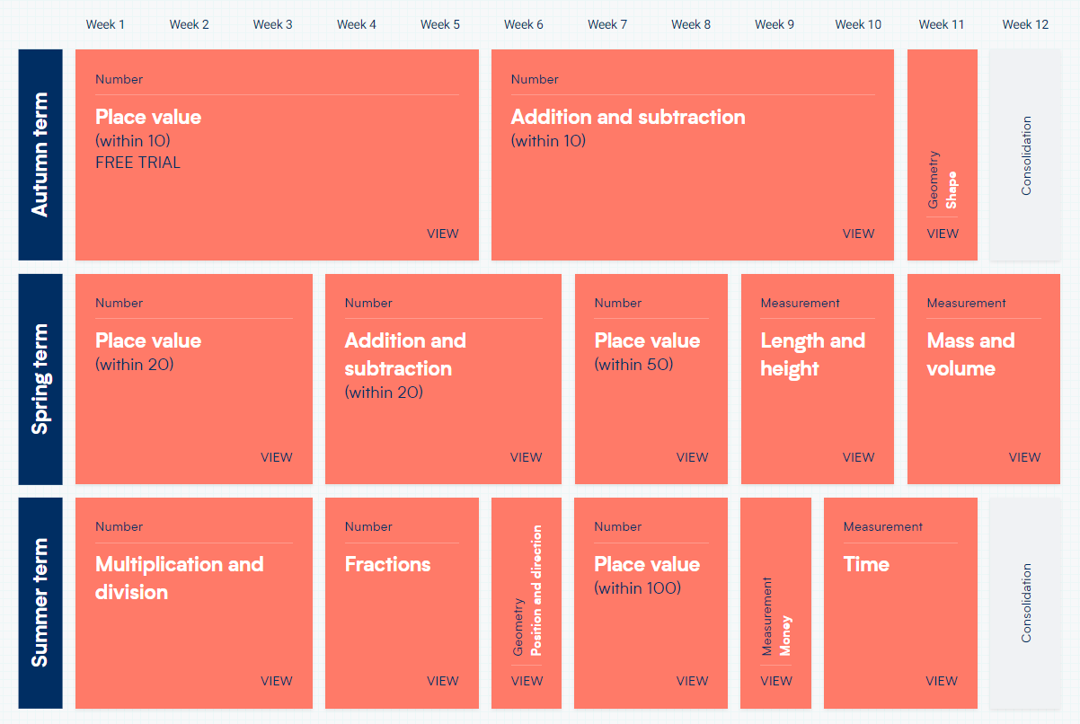

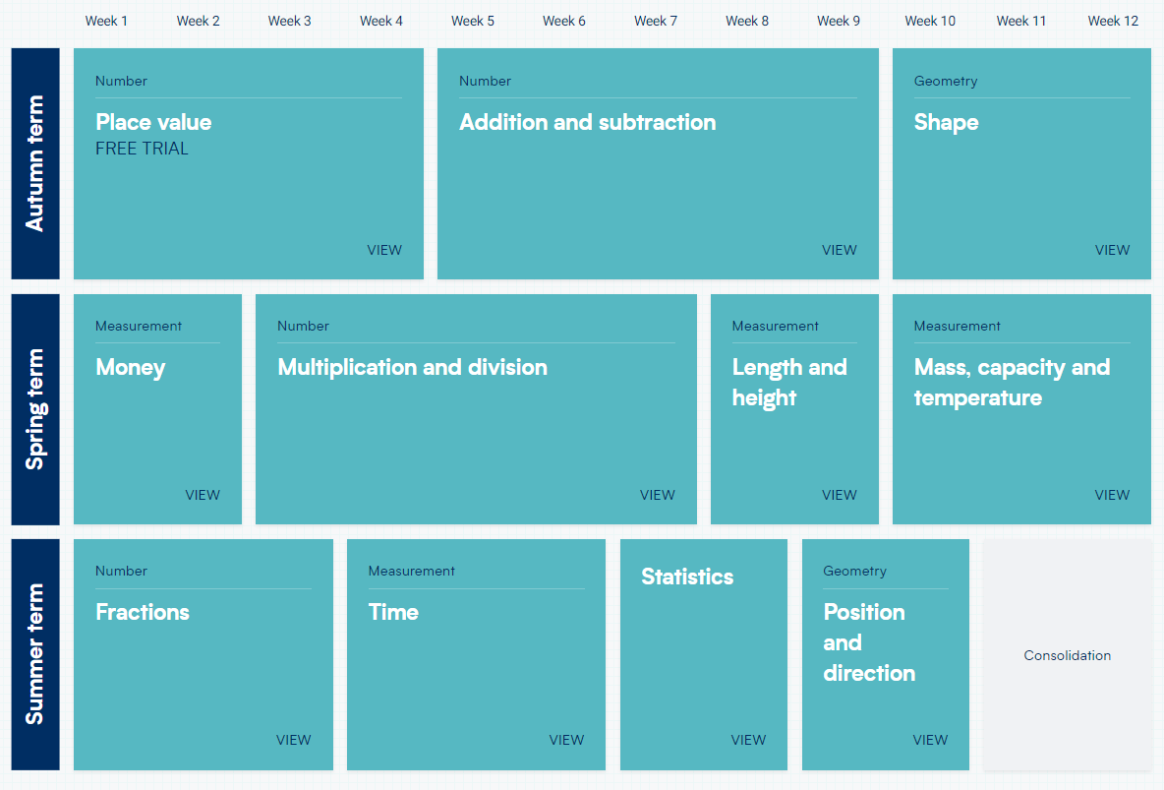
YEAR 2

YEAR 3
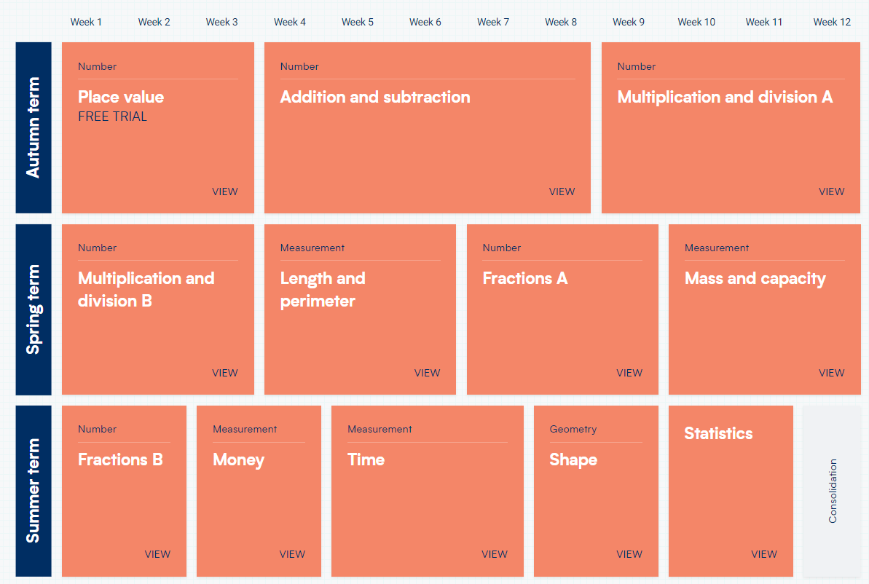

YEAR 4
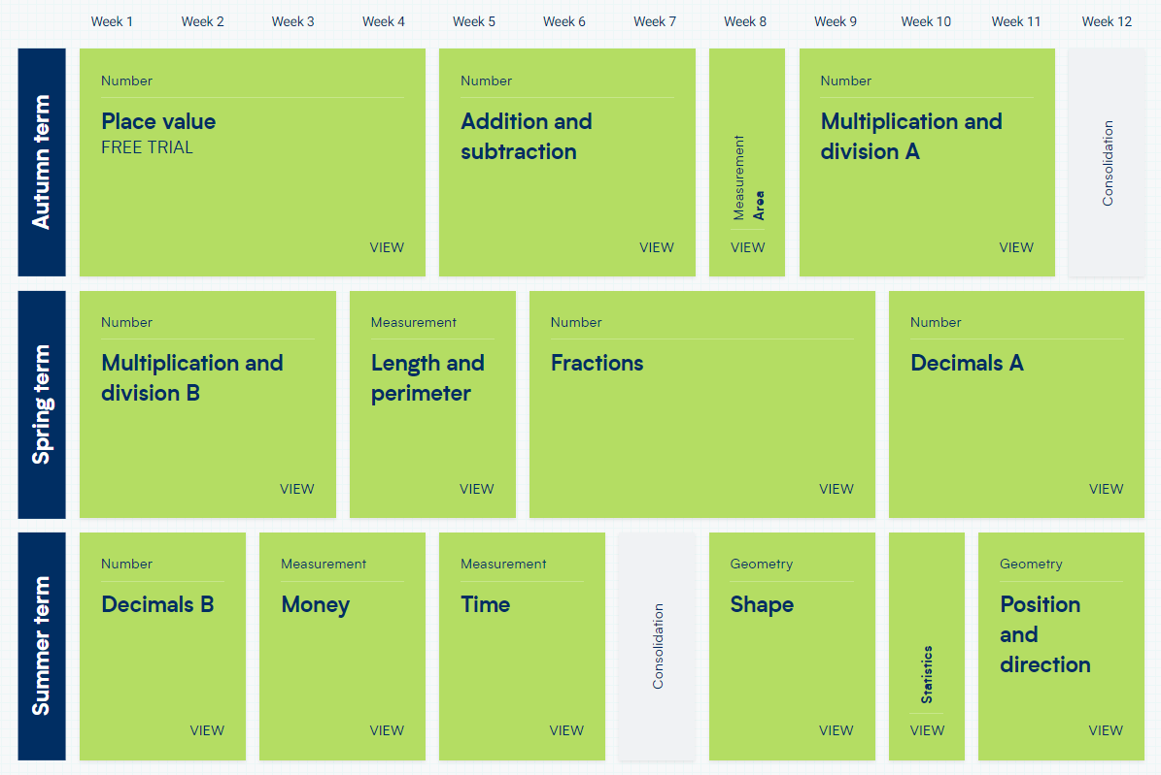

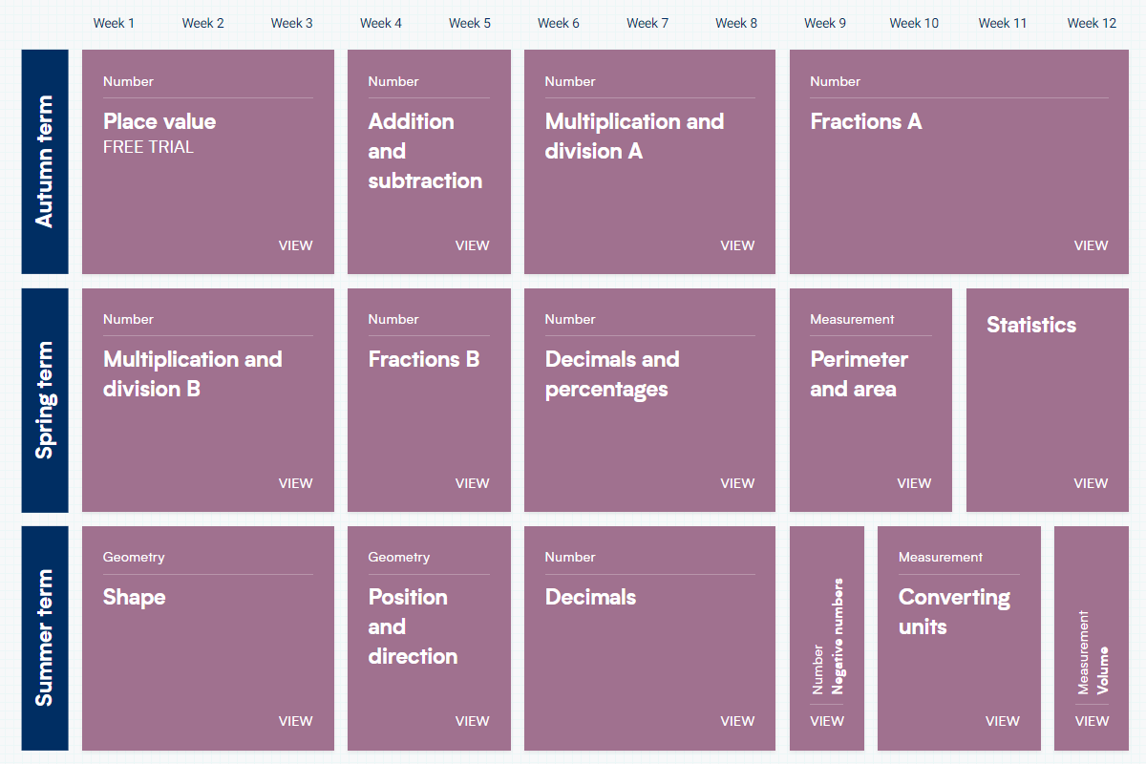
YEAR 5

YEAR 6
